三章 爬取CSDN博文并写入文件

使用步骤
1、Creating a project
2、Defining our Item
3、Writing a spider
4、Writing an Item Pipeline
5、Execute crawl
问：把网站装进爬虫里，总共分几步？
答案很简单，四步：
- 新建项目 (Project)：新建一个新的爬虫项目
- 明确目标（Items）：明确你想要抓取的目标
- 制作爬虫（Spider）：制作爬虫开始爬取网页
- 存储内容（Pipeline）：设计管道存储爬取内容

明确目标：
- 网站：https://blog.csdn.net/oscer2016/article/details/75000148
- 内容：文章的标题、文章的发布日期、阅读数、文章内容、url
在网页中定位和查找内容：
- 标题：<h1 class="title-article"> 标题</h1>
- 文章的发布日期：<span class="time">2017年07月11日 23:09:17</span>
- 阅读数<span class="read-count">阅读数：6598</span>
- 文章内容：<div class="markdown_views">文章内容</div>

本篇将介绍 Scrapy 爬取 CSDN 博文详情页并写入文件，这里以 https://blog.csdn.net/oscer2016/article/details/75000148 这篇博文为例.

- 创建一个爬虫工程
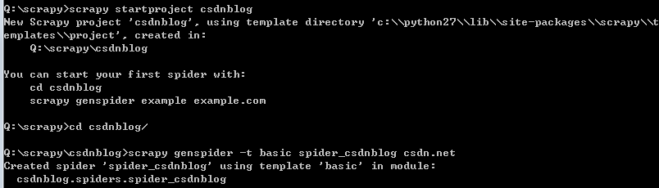
- 编写配置信息
Q:\scrapy\csdnblog\csdnblog\settings.py
# 修改以下两处
USER_AGENT = 'Mozilla/5.0 (X11; Linux x86_64) AppleWebKit/537.36 (KHTML, like Gecko) Chrome/60.0.3112.113 Safari/537.36'
ITEM_PIPELINES = { 'csdnblog.pipelines.CsdnblogPipeline': 300, }
- 编写要抽取的数据域 (items.py) :
Q:\scrapy\csdnblog\csdnblog\items.py
# -*- coding: utf-8 -*-
# Define here the models for your scraped items
#
# See documentation in:
# https://doc.scrapy.org/en/latest/topics/items.html
import scrapy
class CsdnblogItem(scrapy.Item):
# define the fields for your item here like:
# name = scrapy.Field()
title = scrapy.Field()
url = scrapy.Field()
releaseTime = scrapy.Field()
readnum = scrapy.Field()
article = scrapy.Field()

- 编写 piplines.py
findall(pattern, string, flags=0)
当正则表达式中有两个括号时，其输出是一个list 中包含2个 tuple,从输出的结果可以看出，有两个元组，每一个元组中有两 个字符串
Q:\scrapy\csdnblog\csdnblog\pipelines.py
import sys
reload(sys)
sys.setdefaultencoding("gbk")
import re
class CsdnblogPipeline(object):
def process_item(self, item, spider):
data = re.findall("http://blog.csdn.net/(.*?)/article/details/(\d*)", item['url'])
print data
# 构造文件名
filename = data[0][0] + '_' + data[0][1] + '.txt'
text = "标题: " + item['title'] + "\n博文链接: " + item['url'] + "\n发布时间: " \
+ item['releaseTime'] + "\n\n正文: " + item['article']
fp = open(filename, 'w')
fp.write(text)
fp.close()
return item

- 编写爬虫代码
extract后会把selector对象转换成list类型了
Q:\scrapy\csdnblog\csdnblog\spiders\spider_csdnblog.py
# -*- coding: utf-8 -*-
import scrapy
import re
from scrapy import Request
from csdnblog.items import CsdnblogItem
import sys
reload(sys)
sys.setdefaultencoding("utf-8")
class SpiderCsdnblogSpider(scrapy.Spider):
name = 'spider_csdnblog'
allowed_domains = ['csdn.net']
start_urls = ['https://blog.csdn.net/oscer2016/article/details/75000148']
def parse(self, response):
item = CsdnblogItem()
# 新版主题博客数据抽取
item['url'] = response.url
print item['url']
item['title'] = response.xpath('//h1[@class="title-article"]/text()').extract()[0].encode('utf-8')
print item['title']
item['releaseTime'] = response.xpath('//span[@class="time"]/text()').extract()[0].encode('utf-8')
print item['releaseTime']
item['readnum'] = response.xpath('//span[@class="read-count"]/text()').extract()[0]
print item['readnum']
print(response)
t = response.xpath("//div[@class='markdown_views']//*/text()").extract()
text=""
try:
for a in range(0,len(t)):
text=text+t[a].encode('utf-8')
item['article'] = text
except Exception,e:
print(e)
yield item
注意：
这样写是获取所有的节点：t=html.xpath("//div[@class='markdown_views']//*/node()")

- 运行项目:

